A l p h a l i z e T e c h n o l o g i e s

369 Attendance

Employee Guide
Check in, check out, and ask for the days you need.

About This Guide
This is the guide for everyone who uses 369 Attendance, from Alphalize Technologies, to record their own working day: checking in and out, working on a day off, applying for leave, asking to work from home, and looking back over the month.
It describes the app exactly as it behaves on the phone. Every button name, field label and message in this guide is quoted from the app itself, so what you read here is what you will see on the screen.
HR staff and administrators use this guide too. Their own attendance, leave and work-from-home days work exactly as they do for everyone else. What they approve and configure is covered in two separate documents, the HR Guide and the Administrator Guide.
TIP HR staff and administrators see a third tab in the middle of the bar along the bottom, labelled HR or Config. Everything in this guide happens on the other two tabs, Home and Profile, which look the same for everyone.

369 Attendance at a Glance
▪ Once — connect the phone to your company's server and sign in. The app remembers both.
▪ Every working day — tap Check In when you start and Check Out when you finish.
▪ On a weekly off or holiday you work — tap I'm working today first, then check in; the day earns you a compensatory off.
▪ When you need time away — open Apply Leave, pick the dates, give a reason, and read any red Loss of Pay warning before you submit.
▪ When you want to work from home — open Work From Home, request the day, and check in as usual once it is approved.
▪ Whenever you like — look back over My Attendance and check My Details.

PART 1 GETTING STARTED

Step 1 Connect to Your Company's Server
The app opens on a short splash screen showing 369 Attendance, Attendance, leave & WFH in one place and by Alphalize Technologies. The very first time, it then asks where your company's server is.
The screen is headed Connect to your server and marked STEP 1 OF 2. Type the address your HR team gave you into Server URL. You do not need to press anything: once the address looks complete the app shows Fetching databases… and looks up the databases on that server by itself.
If the server has only one database, it is chosen for you and you will see 1 database found · selected automatically. If there are several, tap Database (it reads Select a database until you choose) and pick yours from the Select database list. Then tap Continue.
If you leave off the http:// or https:// at the start, the app adds the right one for you: plain http for an address on your office network, https for anything else.
What you see | What it means
Databases load automatically once the address looks complete. | Keep typing; nothing has been looked up yet
No databases found on this server. | The address answered but there is nothing to sign in to. Check the address with HR
This server does not publish its database list. Enter the database name manually below. | Tap Enter database manually and type the name HR gave you into Database name
Cannot reach the server. | The phone could not reach that address. Check it, and check the phone is on the right network
Retry | Asks the server again without retyping

TIP Your server address is stored on this device only. You are asked for it once. After that the app goes straight to the sign-in screen, or straight to Home if you are already signed in.

[ IMAGE 1 — not captured yet ]
The server screen — Server URL, the database found for you, and Continue

Step 2 Sign In
The sign-in screen says Welcome back and Sign in to continue, and is marked STEP 2 OF 2. At the top, a strip shows the server and database you are about to sign in to.
Type your Username and Password and tap Sign In. The eye at the end of the password box shows what you have typed.
If you see this | What to do
Username is required or Password is required | Fill in the empty box
Invalid username or password. | Check both and try again; passwords are case-sensitive
Contact your HR administrator to reset your password. | This is what Forgot password? tells you. There is no reset inside the app
No employee record is linked to your user account. Please contact HR. | You signed in, but HR has not yet linked your login to an employee. Home cannot load until they do

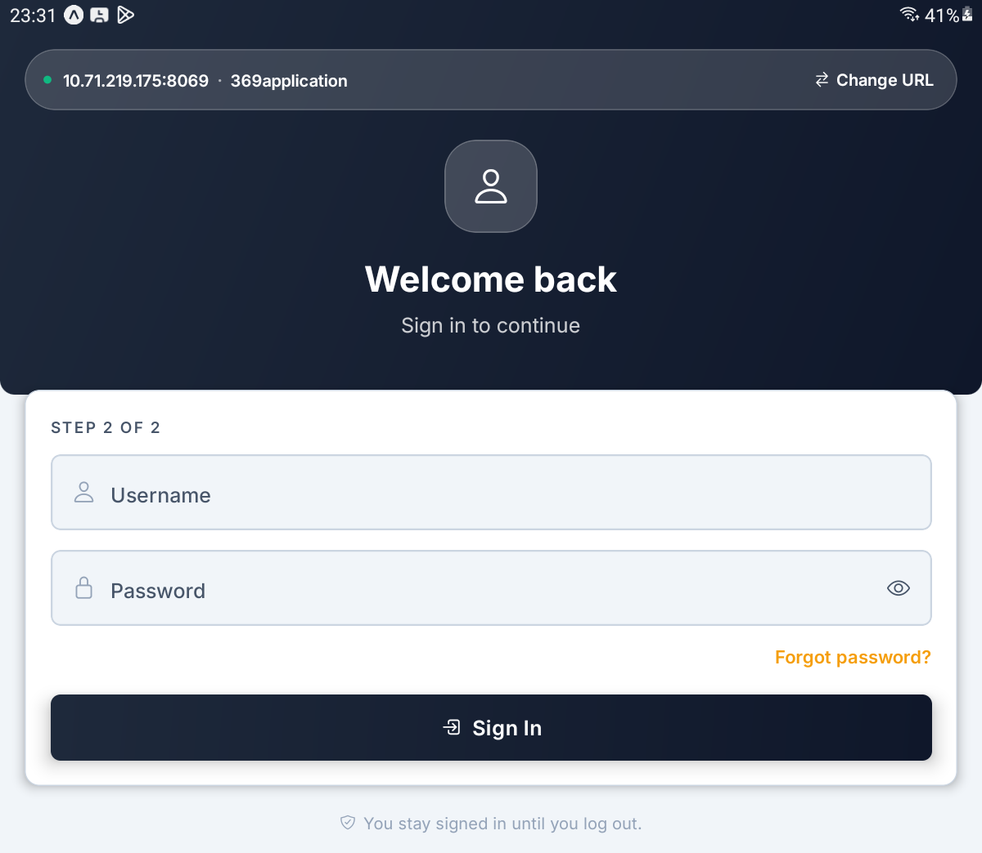
The sign-in screen — the server strip with Change URL, Username, Password and Sign In

Step 3 Stay Signed In, Log Out, or Change Server
You stay signed in until you log out. Closing the app, restarting the phone or coming back days later all return you straight to Home.
To sign out, tap the log-out button at the far right of the Home header. The app asks Log out? — You will need to enter your username and password again. The server and database stay saved. Tap Log out to confirm.
To point the app at a different server, sign out first, then tap Change URL in the strip at the top of the sign-in screen. It asks Change server? — You'll be signed out and asked for the server URL and database again. Tap Change server and you are back at Step 1.
What you tap | What it clears
Log out | Your sign-in only. Next time you type your username and password; the server is remembered
Change URL, then Change server | Your sign-in and the server. Next time you start again from Step 1

IMPORTANT If you ever see Your session has expired. Please sign in again., log out and sign back in. Nothing you saved is lost.

[ IMAGE 3 — not captured yet ]
The Log out? confirmation over Home, with Cancel and Log out

PART 2 YOUR HOME SCREEN

Step 4 Find Your Way Around Home
Home opens with a greeting — Good morning, Good afternoon or Good evening — and your name. Under it is today's date.
Four round buttons sit at the top right.
What you tap | What happens
Moon or sun | Switches between the dark and light look. The app always opens light again next time
Bell | Shows No new notifications. The app has no notifications yet, so the small dot on the bell is always there and means nothing
Gear | Opens Settings, which shows the server you are connected to (Step 24)
Log-out arrow | Asks Log out? (Step 3)

Below the header is the attendance card: a live clock, a status chip, your Check In and Check Out times for today, and one big button. Under the card, a line gives your office rules, for example Office 08:00–17:00 · 15 min grace.
Pull the screen down at any time to refresh everything on it.
TIP Pressing the phone's back button on Home does nothing. That is deliberate, so a stray press never closes the app halfway through your day.

[ IMAGE 4 — not captured yet ]
Home on an ordinary working day — the greeting, the four header buttons, and the attendance card showing Not checked in

Step 5 Check In and Check Out
When you arrive, tap Check In. The app confirms with Checked in. Have a productive day! The chip changes to Checked in with a running timer, your arrival time fills in under Check In, and the button turns red and reads Check Out.
When you finish, tap Check Out. The app confirms with Checked out. Have a good evening! The chip reads Done for today and the button greys out as Checked out for today.
There is nothing else to do: no photo, no location, no reason to type. The server grades the day from your check-in time against your office hours. Arrive after the grace period and the day is marked Late; the app does not stop you or ask why.
What the chip says | What it means
Not checked in | You have not started today
Checked in · time | You are in; the figure counts your time since check-in
Done for today | You have checked out. Today is closed
WFH | Today is an approved work-from-home day (Part 5)

IMPORTANT There is no "are you sure?" on Check Out. One tap closes your day, and once you have checked out you cannot check in again until tomorrow. If you are only stepping out, do not check out.

[ IMAGE 5 — not captured yet ]
Checked in — the green Checked in chip with its timer, the check-in time, and the red Check Out button

Step 6 Read Today's Figures and the Month
Three tiles sit under the attendance card.
Tile | What it shows
Worked | Hours worked today, such as 0h 00m
Status | How the server has graded today: Present, Late, Half Day, Leave, Absent or Day Off. Until the day has a grade it simply reads Present
Late by | On time, or how late you were

Below them, a card headed with the month and year counts this month's Present, Late, Absent and Leave days.
At the bottom, Recent activity lists your most recent graded days this month, up to ten, each with its date, the in and out times, the hours worked and a status chip. Until you have checked in at least once it says No check-ins yet and Your last five days show here once you check in.
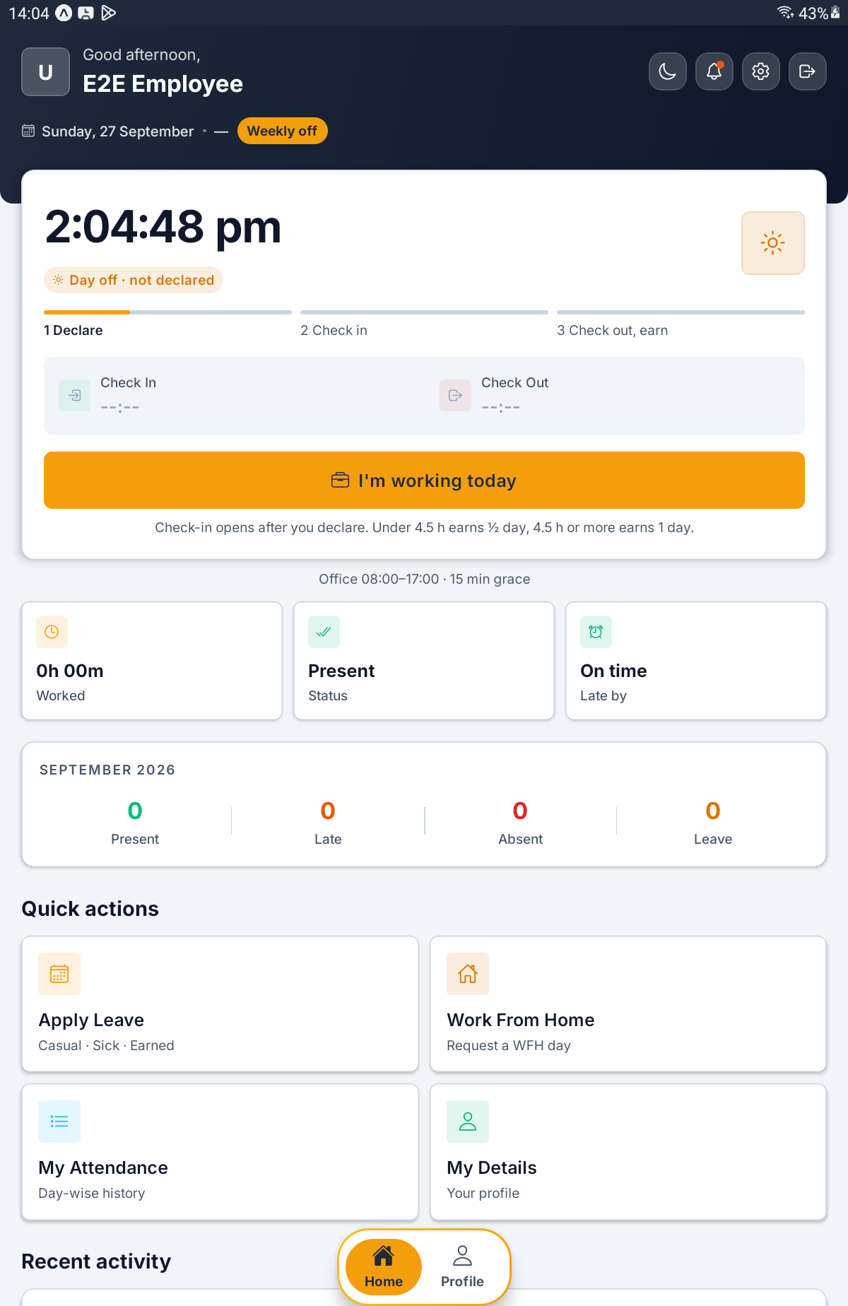
Home further down — the three tiles, the month card, Quick actions and Recent activity

Step 7 Use the Quick Actions and the Tabs
The four Quick actions tiles take you to everything else in the app.
What you tap | Where it goes
Apply Leave — Casual · Sick · Earned | Your leave (Part 4)
Work From Home — Request a WFH day | Your work-from-home requests (Part 5)
My Attendance — Day-wise history | Your month, day by day (Step 22)
My Details — Your profile | The Profile tab (Step 23)

Along the bottom of Home and Profile floats a bar with two tabs, Home and Profile. The tab you are on is filled in amber. Leave, Work from home, My attendance and Settings open on top of Home and cover the bar; the arrow at their top left, or the phone's back button, brings you back.
TIP The Apply Leave tile says Earned, but there is no leave type by that name. The nearest one on the form is Annual.

PART 3 WORKING ON A DAY OFF

Step 8 Spot a Day Off
On your weekly off, an amber pill beside the date reads Weekly off. On a public holiday it shows the holiday's name followed by · holiday.
If your company requires it, the attendance card changes on these days. The chip reads Day off · not declared, a three-part bar appears — 1 Declare, 2 Check in, 3 Check out, earn — and the big button reads I'm working today instead of Check In. The line under it tells you how the day is paid back, for example Check-in opens after you declare. Under 4.5 h earns ½ day, 4.5 h or more earns 1 day.
The server will not accept a check-in on these days until you have declared that you are working.
TIP If the pill appears but the card still shows an ordinary Check In button, your company does not ask for the declaration. Check in as normal.

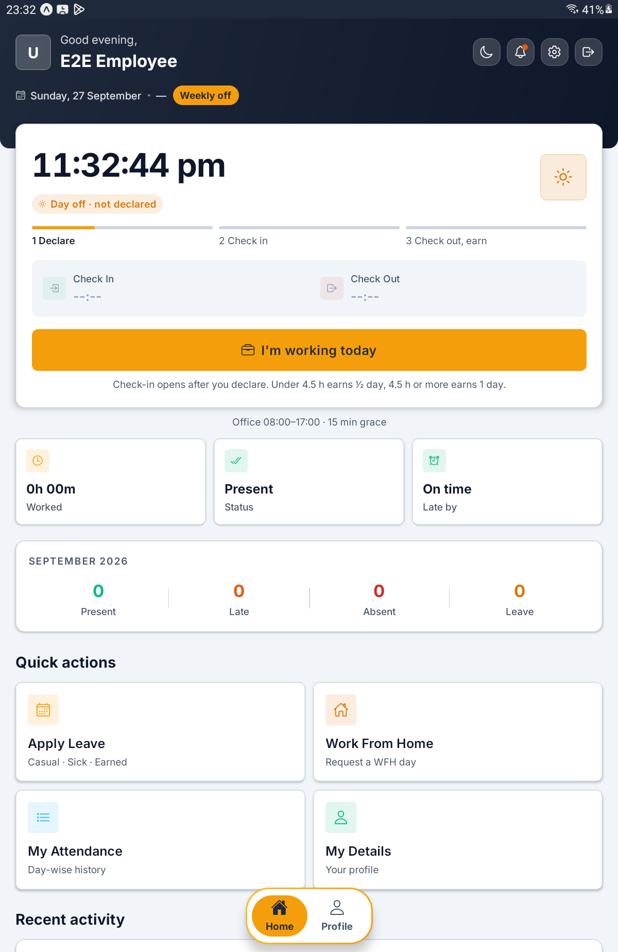
Home on a weekly off — the Weekly off pill, the Day off · not declared chip, the three-step bar and I'm working today

Step 9 Declare That You Are Working
Tap I'm working today. The app asks Working today? and explains, for example, Today is your weekly off. Check-in opens for today, and your hours earn a comp-off: under 4.5 h is half a day, 4.5 h or more is a full day.
Tap I'm working today again to confirm. The app answers Marked as a working day. You can check in now., the chip changes to Working today · declared and the first part of the bar fills.
What you tap | What happens
I'm working today on the card | Opens the confirmation
I'm working today in the window | Declares the day and opens check-in
Cancel | Leaves the day as a day off

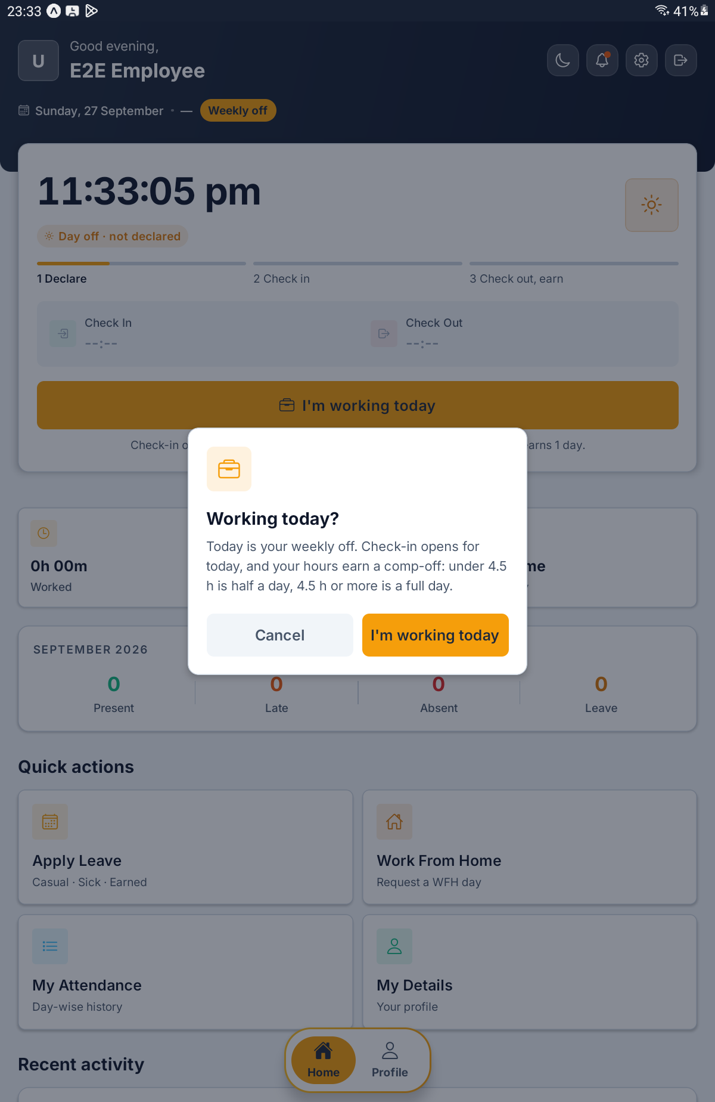
The Working today? window with Cancel and I'm working today

Step 10 Check In, or Change Your Mind
Once declared, the button reads Check In and the line under it says Declared. Check in when you start. Tap Check In when you begin work, exactly as on any other day.
Changed your plans? Until you check in, a link under the button reads Not working after all. Tap it and the declaration is withdrawn; the app says Enjoy your day off. Once you have checked in, the link disappears.
TIP A declaration you never use costs nothing. If the day passes without a check-in, the server drops it and it earns nothing.

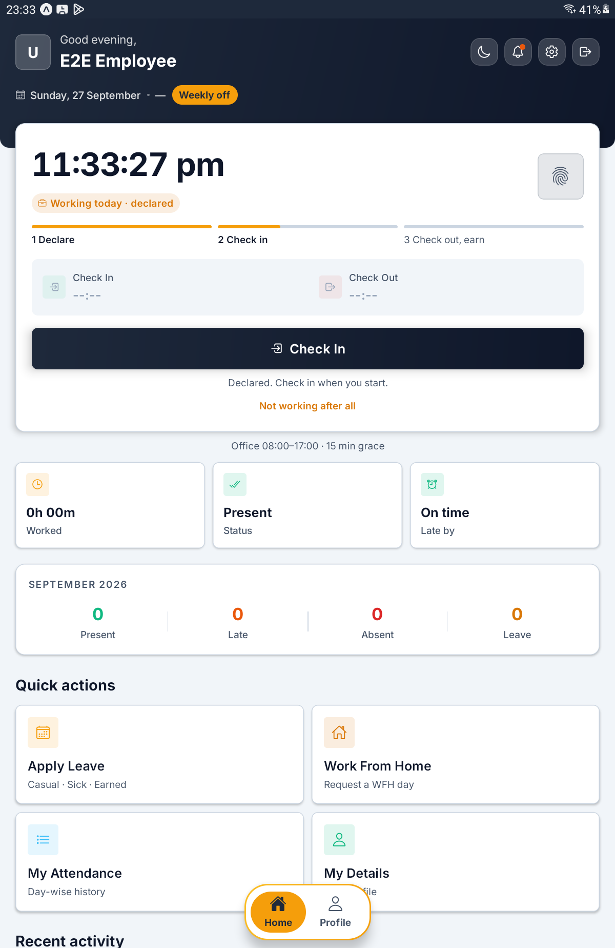
Declared — Working today · declared, the Check In button, and the Not working after all link

Step 11 Check Out and Earn Your Comp-Off
While you are checked in, the line under Check Out reminds you of the full-day mark, for example Check out after 4.5 h for a full comp-off day.
When you check out, the server works out what the day earned from the hours you actually worked: below the mark earns half a day, the mark or more earns a full day. For a moment the card may say Comp-off is being sized from your hours.; then it reads Earned ½ day of comp-off. or Earned 1 day of comp-off.
The day shows as Day Off in your records. It is never counted against you, and the comp-off it earned appears on your Leave screen (Step 12).
What the line says | What it means
Check out after 4.5 h for a full comp-off day. | You are checked in; stay to the mark for a full day
Comp-off is being sized from your hours. | You have checked out; the server is still working it out
Earned ½ day of comp-off. | You worked less than the full-day mark
Earned 1 day of comp-off. | You reached the full-day mark

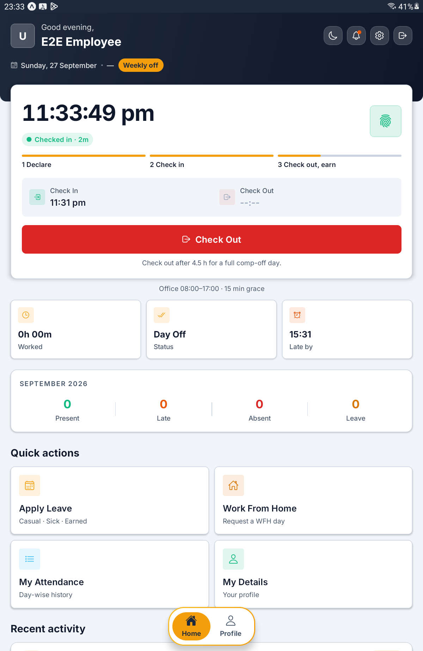
Checked in on a declared day off, with Check out after 4.5 h for a full comp-off day.

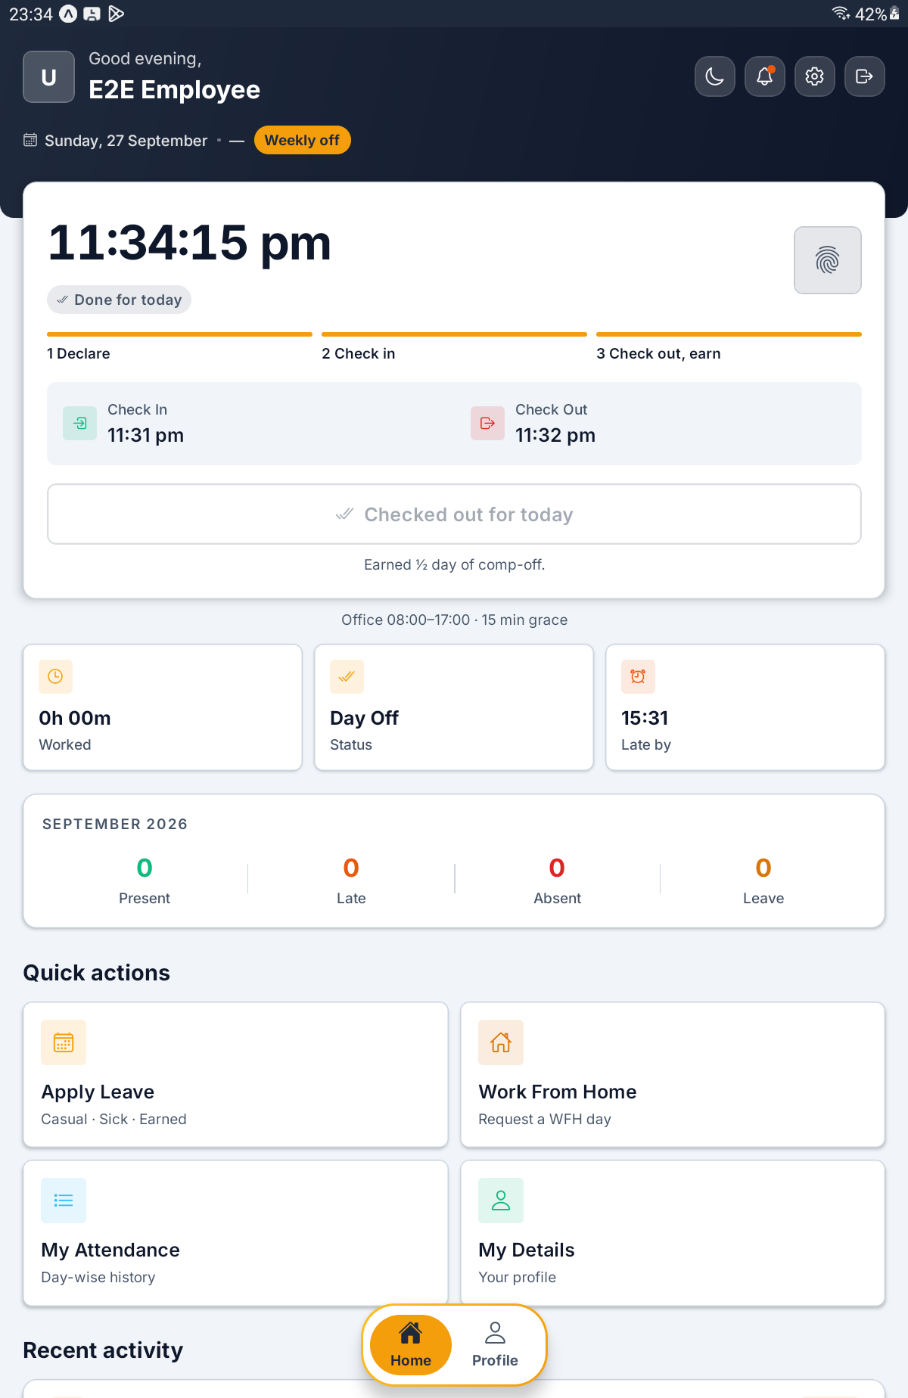
Done for today, with Earned ½ day of comp-off. under the greyed Checked out for today button

PART 4 LEAVE

Step 12 Open Leave and Read Your Balances
Tap Apply Leave on Home. The Leave screen (Apply, track and cancel) shows your balances at the top and your requests underneath.
The Paid leave card shows three figures for this calendar year.
What you see | What it means
Remaining | Paid days you still have this year
Used | Paid days already taken
Allowed | Your allowance for the year
Used counts approved leave only | Pending requests are not in Used yet; the line adds how many more are pending approval
1 day/month accrual | How your allowance builds up, if your company sets one
Days beyond your quota are unpaid. | Leave past your allowance is Loss of Pay

Two red lines warn you before you apply that your next leave will be unpaid: This month's paid leave is used. More leave this month is unpaid (LOP). or Paid leave exhausted. New leave is unpaid (LOP). If your company has no paid-leave allowance at all, the card simply says No paid-leave quota is configured. You can still apply for leave.
The Compensatory off card shows the days you have earned by working days off: Available, Used and Earned. With nothing earned yet it says None yet. On a weekly off or public holiday, tap "I'm working today" on Home and the day earns one. If your company does not use comp-off, the card is not shown at all.
IMPORTANT Paid leave does not carry forward. Each calendar year starts again from your allowance, and unused days do not move across. Comp-off works differently: whether it carries into the next year, and whether it expires, is set by your company.

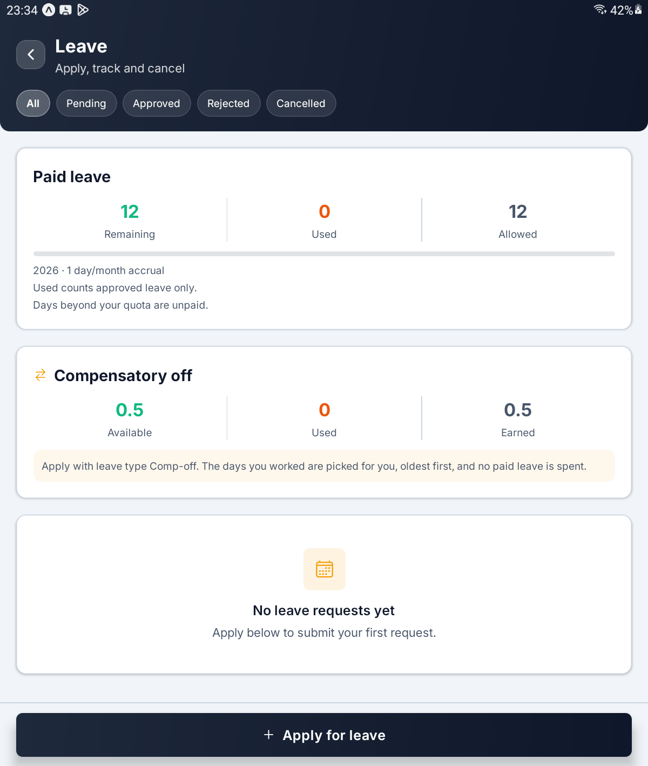
The Leave screen — the Paid leave and Compensatory off cards above the filter chips and the Apply for leave button

Step 13 Fill In a Leave Request
Tap Apply for leave at the bottom of the screen. The Apply for leave form slides up.
Choose a Leave type. The list is fixed: Casual, Sick, Annual, Personal, Emergency and Other, plus Comp-off when you have some to spend (Step 15). Casual is chosen for you to start.
Tap Dates. A small calendar opens: Tap the first day, then the last. For a single day, tap it once. Tapping a day earlier than your first one starts again from there. Today is outlined, and the key at the bottom shows Holiday and Weekly off so you can see the days you already have off. Tap the button at the bottom — it reads Use and the dates you chose — to fill in the form. Cancel leaves the form as it was.
Type a Reason, then tap Submit request. The app says Leave request submitted. and the request appears in your list as Pending.
If you see this | What it means
Pick at least a start date. | Choose your dates first
Give a reason for your leave. | The reason is required
These dates overlap an existing request. | You already have leave on some of these days; the red box below explains which

TIP The day count shown under Dates simply counts calendar days, weekends included. The server counts working days when it decides what is paid, and the red warning in the next step always uses its figure.

IMPORTANT Paid leave is taken in whole days. The Half day switch appears only for Comp-off.

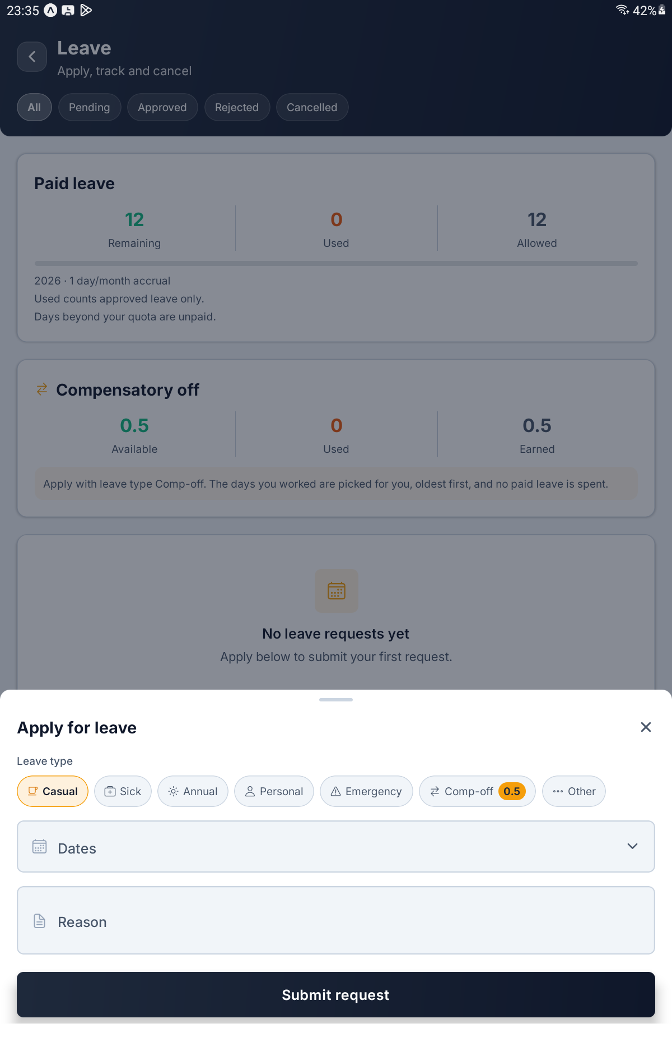
The Apply for leave form — the Leave type chips with Casual chosen, Dates, Reason and Submit request

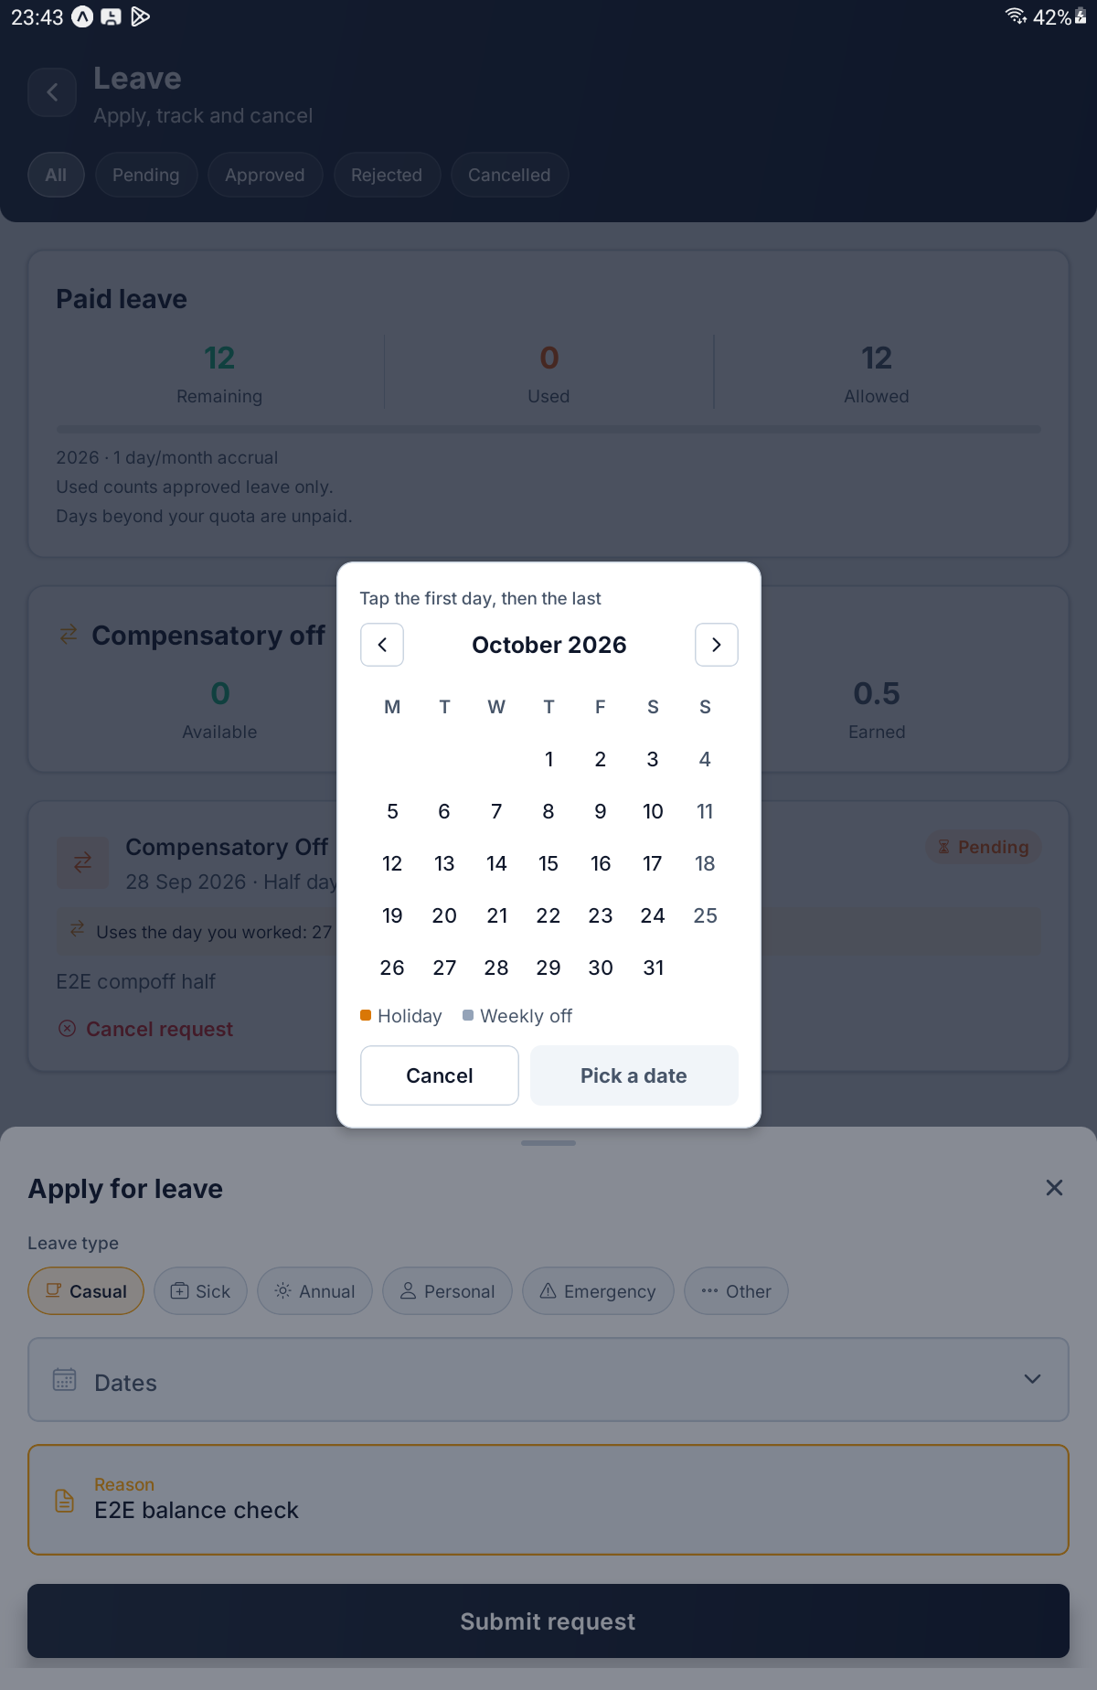
The date calendar — Tap the first day, then the last, with the Holiday and Weekly off key

Step 14 Read the Loss of Pay Warning
As soon as you pick your dates, the server works out how much of the leave it will pay. If any of it would be unpaid, a red box appears at the top of the form, and the submit button tells you how much, for example Submit · 1 day unpaid (LOP).
The box reads one of these:
What the box says | What it means
Only … of these … is paid leave. The other … will be Unpaid Leave / Loss of Pay (LOP). | Part of this leave is paid, the rest is not
Your paid leave for this month (…) is already used. Any additional leave applied this month will be treated as Unpaid Leave / Loss of Pay (LOP). | You have reached this month's limit
Your paid leave balance has already been exhausted. Any additional leave applied will be treated as Unpaid Leave / Loss of Pay (LOP). | Your allowance for the year is gone
Paid leave is not set up for your company, so this leave will be Unpaid Leave / Loss of Pay (LOP). | Your company has no paid-leave allowance

Where your company deducts unpaid days from salary, the box adds and deducted from your salary.
IMPORTANT The warning never stops you. Unpaid leave is a legitimate request and you can still submit it. The box is there so that you find out now, not from your payslip.

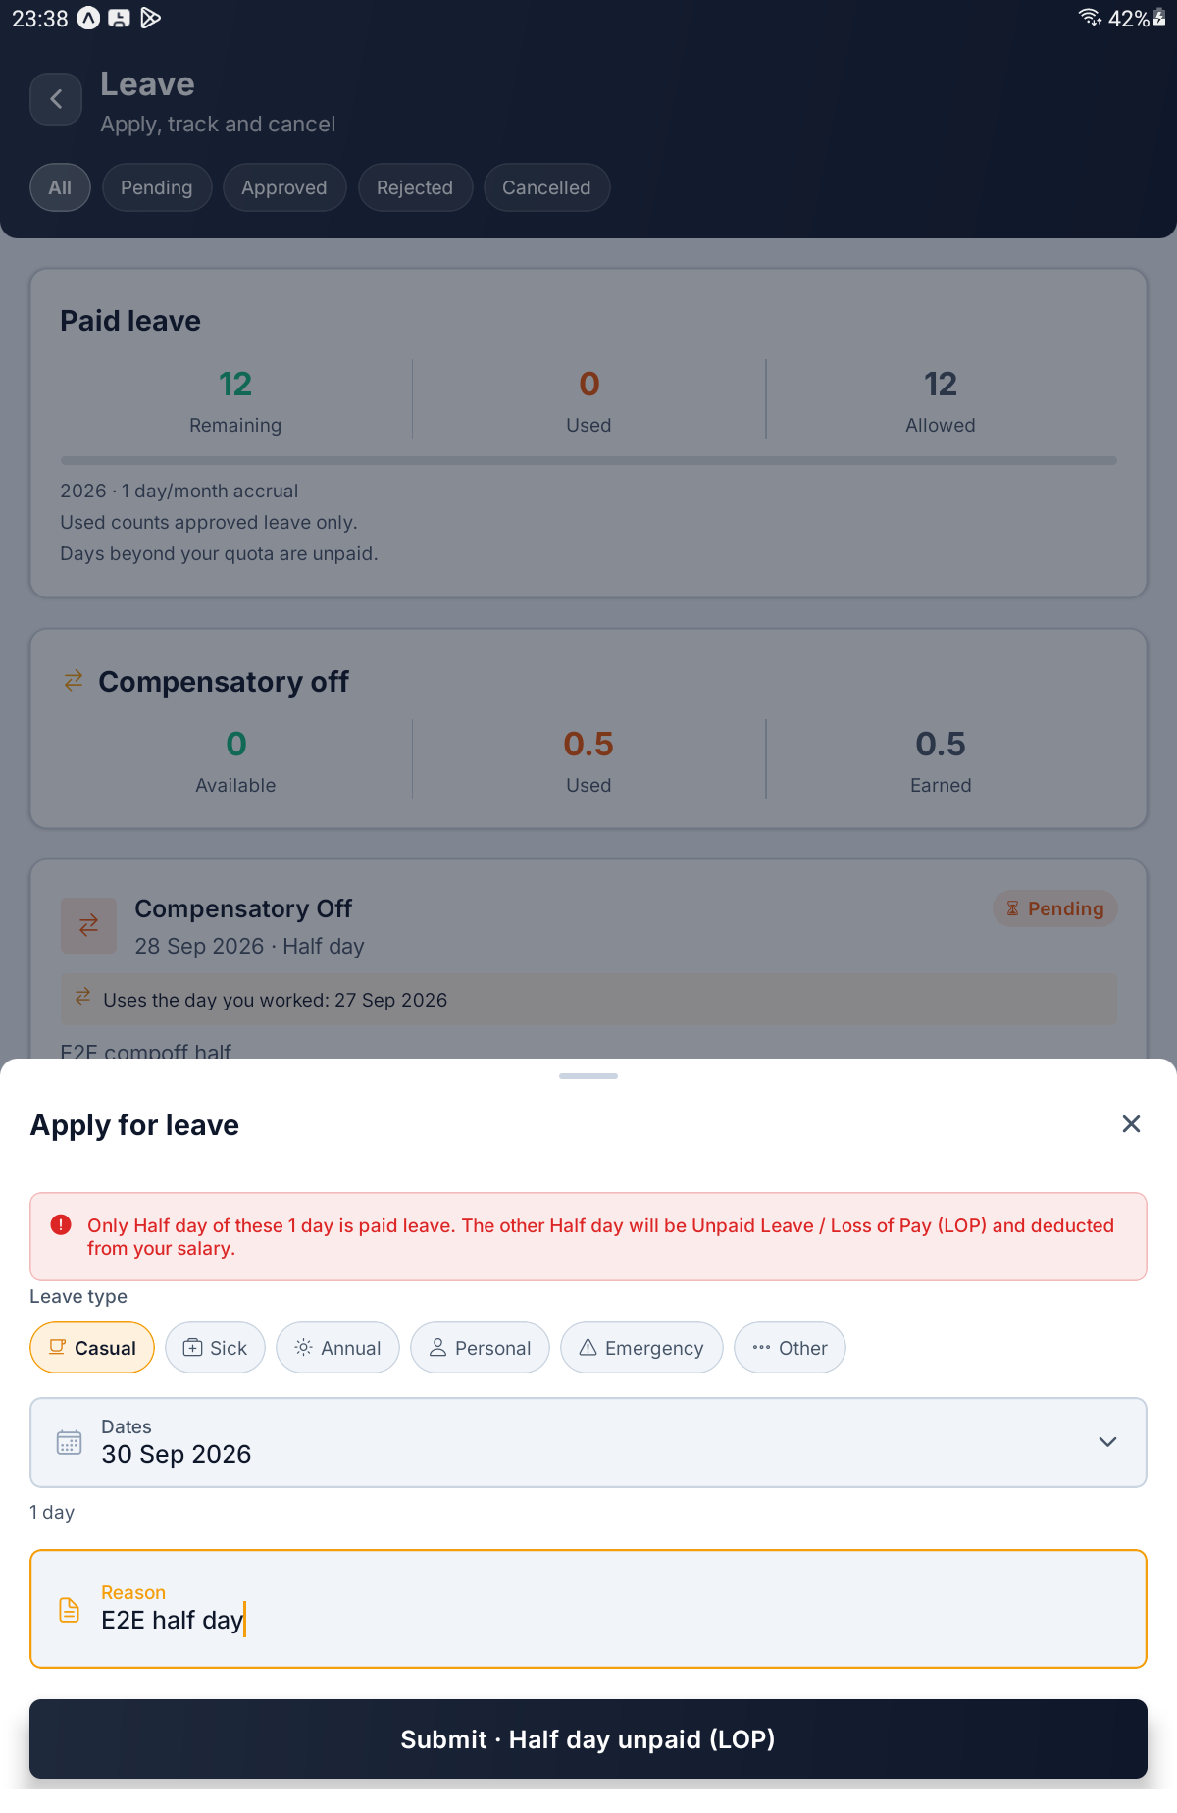
A one-day Casual request that is half unpaid — the red box and Submit · Half day unpaid (LOP)

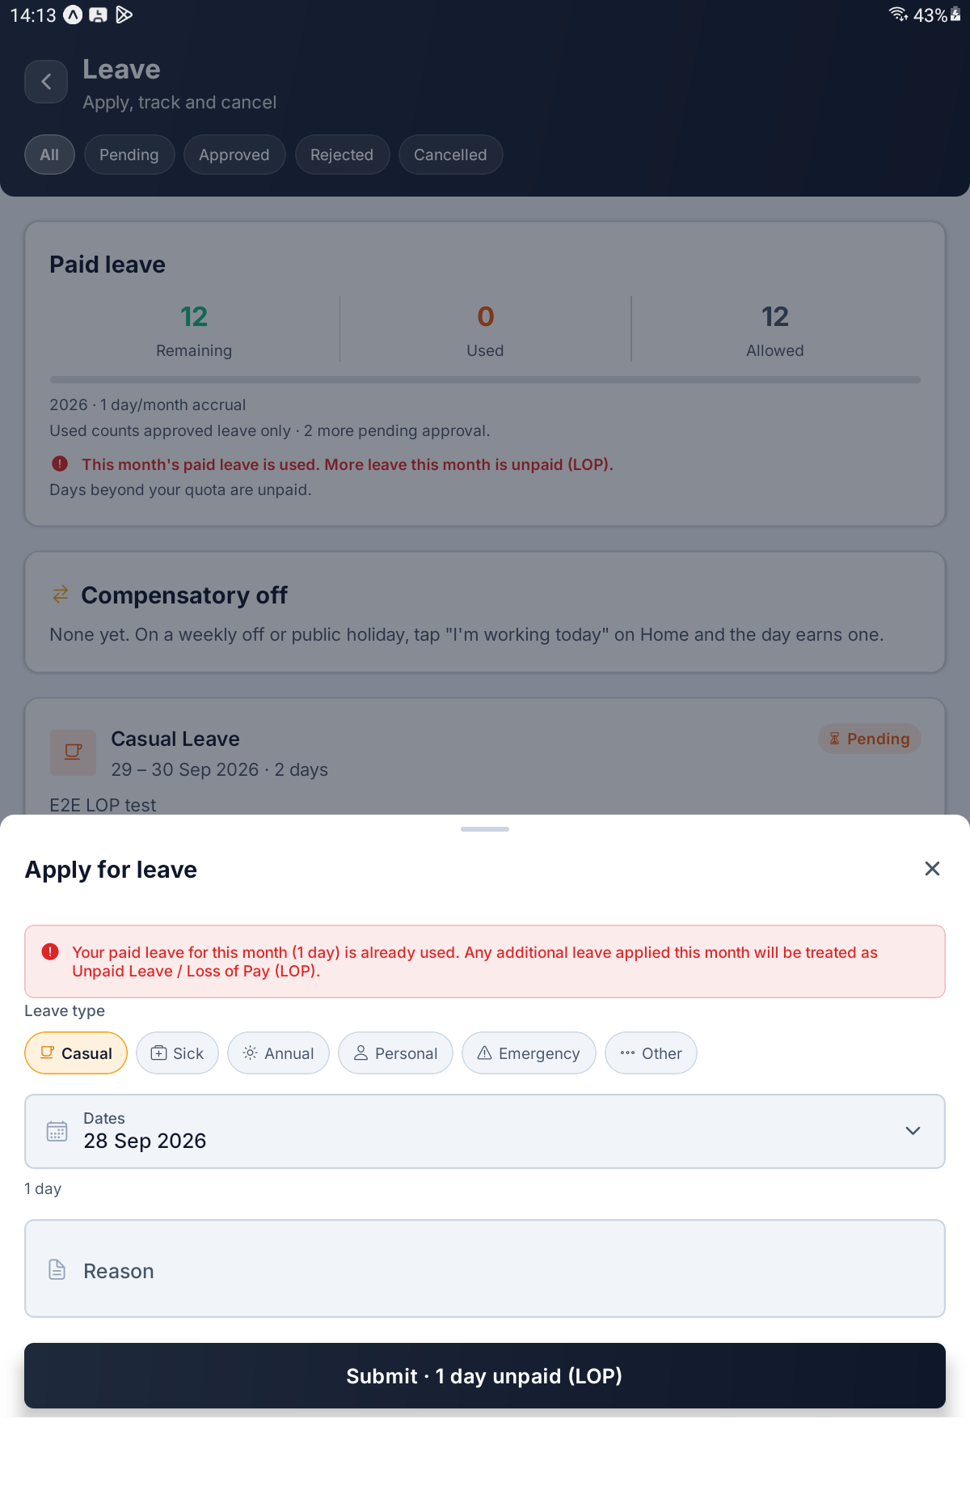
The warning when this month's paid leave is already used, with Submit · 1 day unpaid (LOP)

Step 15 Spend a Comp-Off
When you have comp-off available, a Comp-off chip joins the leave types with your balance beside it. Choose it.
A panel appears saying Pick a date to see which earned days it uses. Once you pick dates it changes to Paid from your earned days, oldest first and lists each day you worked that will pay for this leave, with how much of it is used. You do not choose these; the app picks the oldest first. Anything left over is shown as, for example, ½ day kept for later.
Turn on Half day — Spend ½ day of comp-off on one date — to take half a day. The field then reads Date and takes a single day.
The submit button tells you what it will use, for example Submit · uses ½ day. No paid leave is spent.
If you see this | What to do
This needs … but you have … of comp-off. Pick fewer days or turn on Half day. | You do not have enough; the button stays greyed until you change the dates
Those dates are already days off, so there is nothing to take. | Pick working days instead

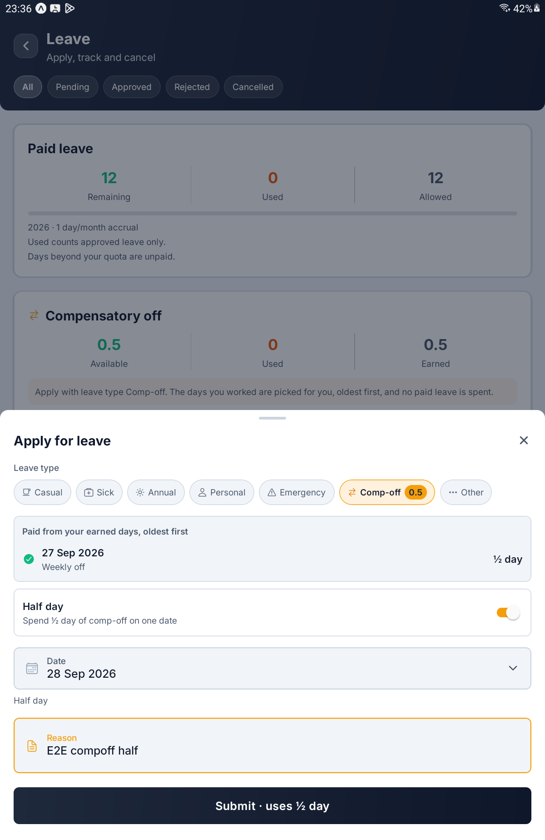
Comp-off chosen with Half day on — the earned day it uses, the date, and Submit · uses ½ day

Step 16 Preview the Email to HR
If your company emails HR when leave is submitted, a Preview email to HR button appears on the form above the submit button.
Tap it to see the Email to HR exactly as HR will receive it, built from what you have typed so far. A line at the top says how many people it goes to, for example Goes to 2 people in HR when submitted. The Review and approve button inside the preview is only a picture of the email; it does nothing here. Tap Close to return to the form.
If the button is not on your form, your company does not send these emails. Your request still reaches HR in the app.
[ IMAGE 18 — not captured yet ]
The Email to HR preview — the recipient line, the email on white paper, and Close

Step 17 Track Your Requests
Every request you make appears on the Leave screen, newest first. Each card shows the leave type, the dates and how many days, a status chip, and your reason.
Status | What it means
Pending | Waiting for HR
Approved | Granted. The line below says Approved by and a name, or Auto-approved
Rejected | Refused. HR's reason is shown in red, or No reason given.
Cancelled | Withdrawn by you, or cancelled by HR at your request

A comp-off request also shows Uses the day you worked: and the date that pays for it.
The chips across the top — All, Pending, Approved, Rejected and Cancelled — narrow the list. If nothing matches you will see, for example, No pending requests and Show all.
TIP The list holds your most recent 50 requests. When it is full, a line at the bottom says Showing the 50 most recent requests. Use the chips to find older ones.

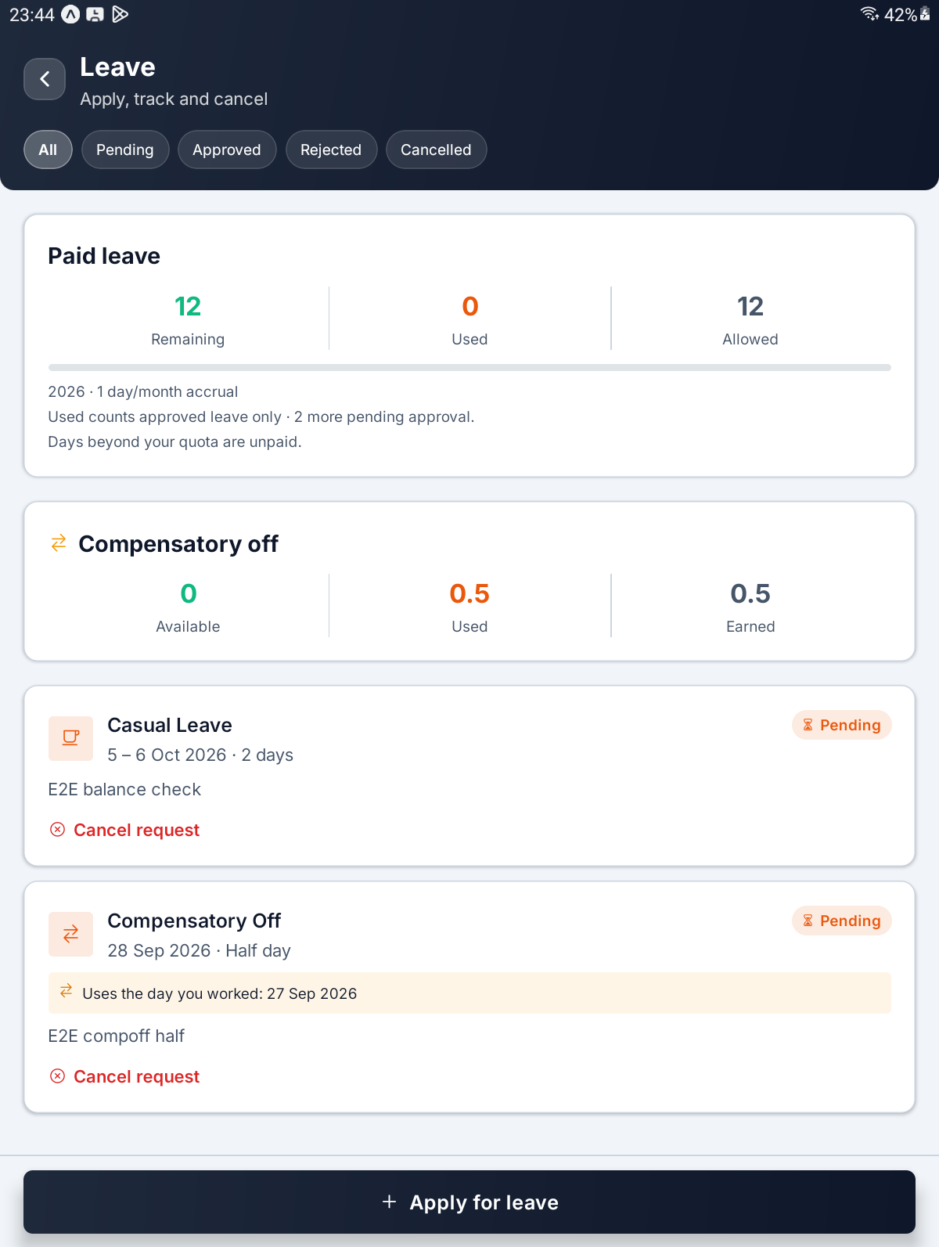
The request list — a pending Casual request and a pending Compensatory Off, each with Cancel request

Step 18 Cancel a Pending Request
While a request is Pending, its card has a red Cancel request link. Tap it.
The app asks Cancel this request? — Your leave for the dates will be withdrawn. You can apply again for the same dates afterwards. Tap Cancel request to withdraw it, or Keep it to leave it alone. You will see Leave request cancelled.
What you tap | What happens
Cancel request on the card | Asks you to confirm
Cancel request in the window | Withdraws it at once. HR does not need to agree
Keep it | Nothing changes

[ IMAGE 20 — not captured yet ]
The Cancel this request? window with Keep it and Cancel request

Step 19 Ask HR to Cancel Approved Leave
Once leave is Approved, you cannot cancel it yourself. Instead its card has an orange Request cancellation link.
Tap it. The app asks Ask HR to cancel this leave? and explains that the leave is already approved, so HR decides. It stays approved until they do. Type why into Why cancel it? — it is required, and if you leave it empty you will see Give a reason — HR sees this. Then tap Send to HR. The app confirms with Cancellation request sent to HR.
The card now says Cancellation requested · waiting for HR. What happens next is HR's decision.
What HR decides | What you see
They agree | The leave becomes Cancelled and its days go back to your balance
They keep it | The leave stays Approved, a red line reads HR kept this leave: and their reason, and Request cancellation is offered again

IMPORTANT Once payroll for the month the leave falls in has been confirmed or paid, the leave can no longer be cancelled. The app shows a message saying the payroll for that period is already confirmed or paid. Talk to HR directly.

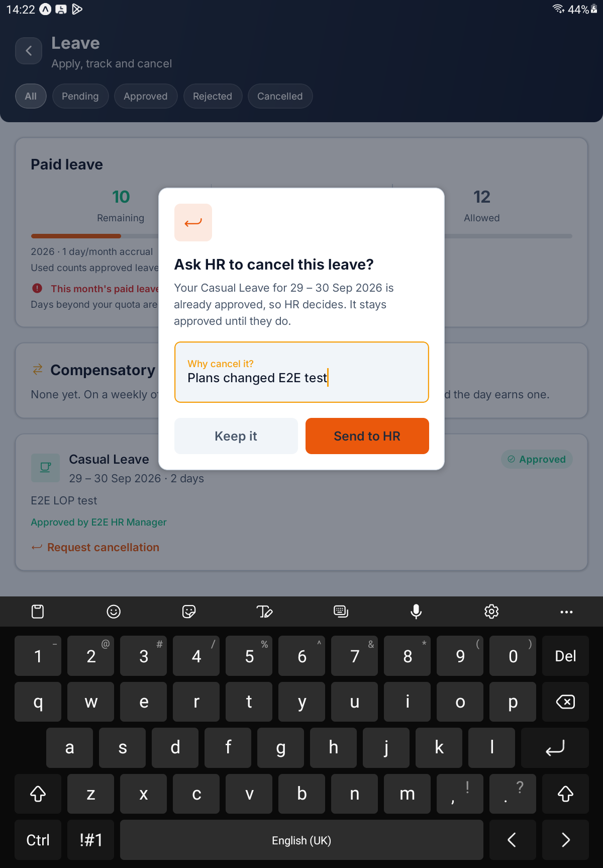
Ask HR to cancel this leave? with a reason typed into Why cancel it?, and Keep it and Send to HR

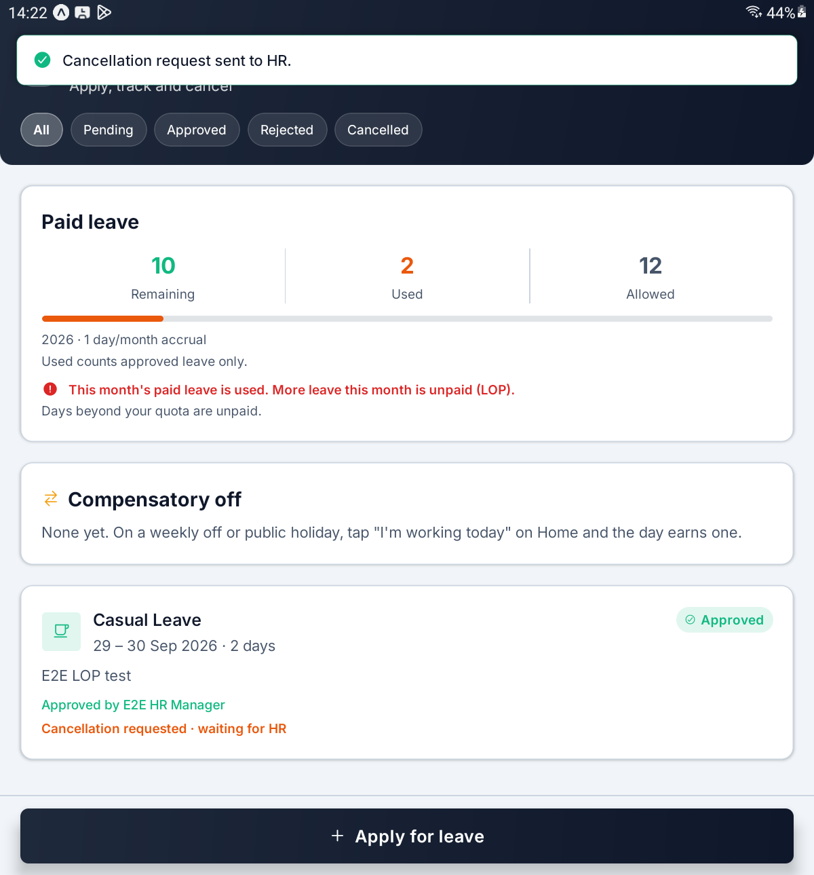
After sending — Cancellation request sent to HR. and Cancellation requested · waiting for HR on the card

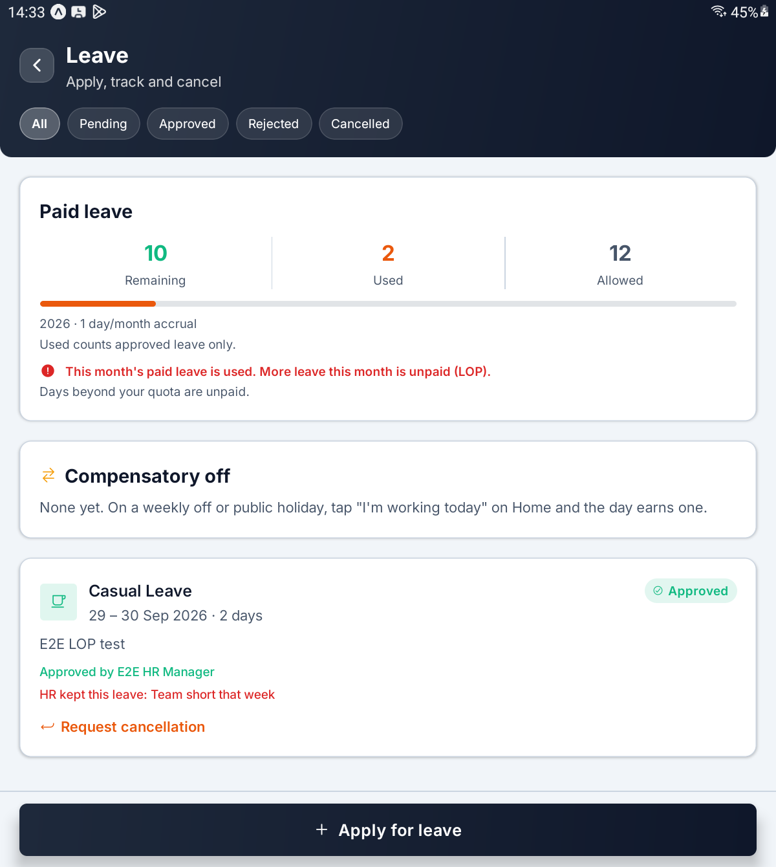
HR kept the leave — HR kept this leave: and the reason, with Request cancellation offered again

PART 5 WORK FROM HOME

Step 20 Request a WFH Day
Tap Work From Home on Home. The Work from home screen (Request a day, track approvals) lists your requests. Tap Request a WFH day at the bottom.
In the form, tap Day and pick a date from the calendar (Pick a day). A WFH day has to be approved before it is worked, so days before today are struck through and cannot be chosen. Type a Reason and tap Submit request. The app says WFH request submitted.
Each request is for one day. For several days, make one request for each.
If you see this | What it means
Pick the day you want to work from home. | Choose the day first
Give a reason for the request. | The reason is required
You already have a request for this day. | There is already a request for that date; the red box below gives its status

TIP As the form says, Once approved, check in as usual on the day — there is no separate WFH button, and your location is not checked. You use the same Check In and Check Out on Home. The app never reads your location on any day, WFH or not.

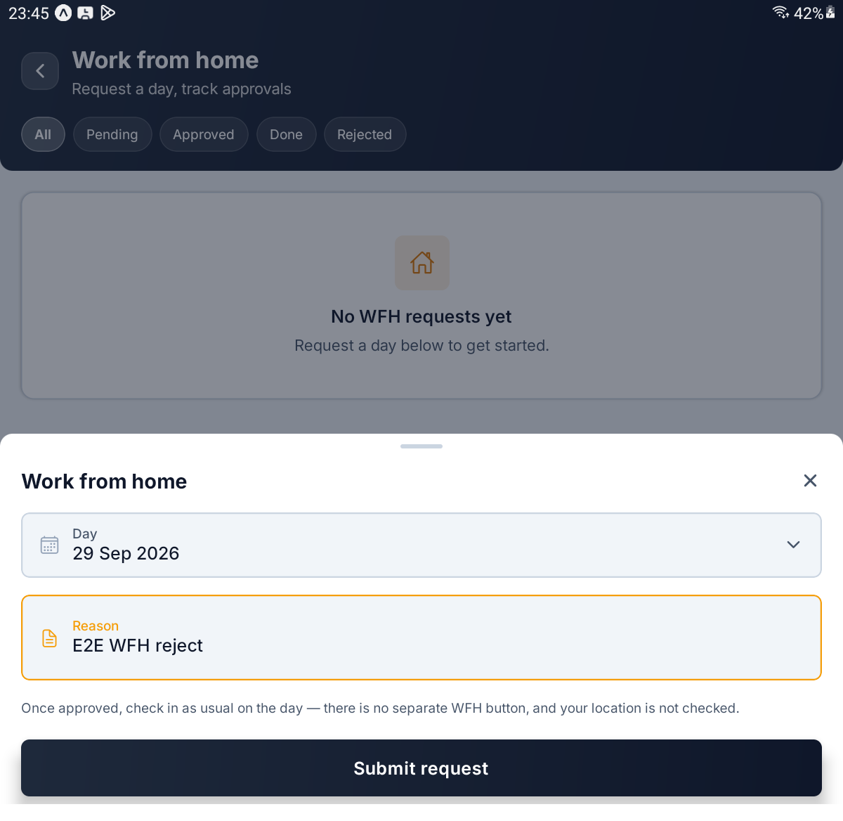
The Work from home form — Day, Reason, the check-in note and Submit request

Step 21 Track and Cancel WFH Requests
Each card shows the date (with Today under it on the day itself), a status chip and your reason. Once you have worked the day, it also shows In, Out and Worked.
Status | What it means
Pending | Waiting for HR
Approved | Granted; the line below says who approved it, or Auto-approved
Working | You are checked in on the WFH day
Done | You have checked out
Rejected | Refused, with HR's reason or No reason given.
Expired | Approved, but the day passed without a check-in
Cancelled | Withdrawn

On an approved WFH day, a green box at the top of the screen reads You are working from home today and Check in from the home screen as usual. Your location will not be checked. Home shows a WFH chip on the attendance card.
To withdraw a request that is Pending or Approved, tap Cancel request on its card, then Cancel request again in the window (Keep it backs out). You will see WFH request cancelled. Once you have checked in on the day, it can no longer be cancelled.
The chips across the top are All, Pending, Approved, Done and Rejected. There is no chip for cancelled requests; they appear under All. The list holds your most recent 50.
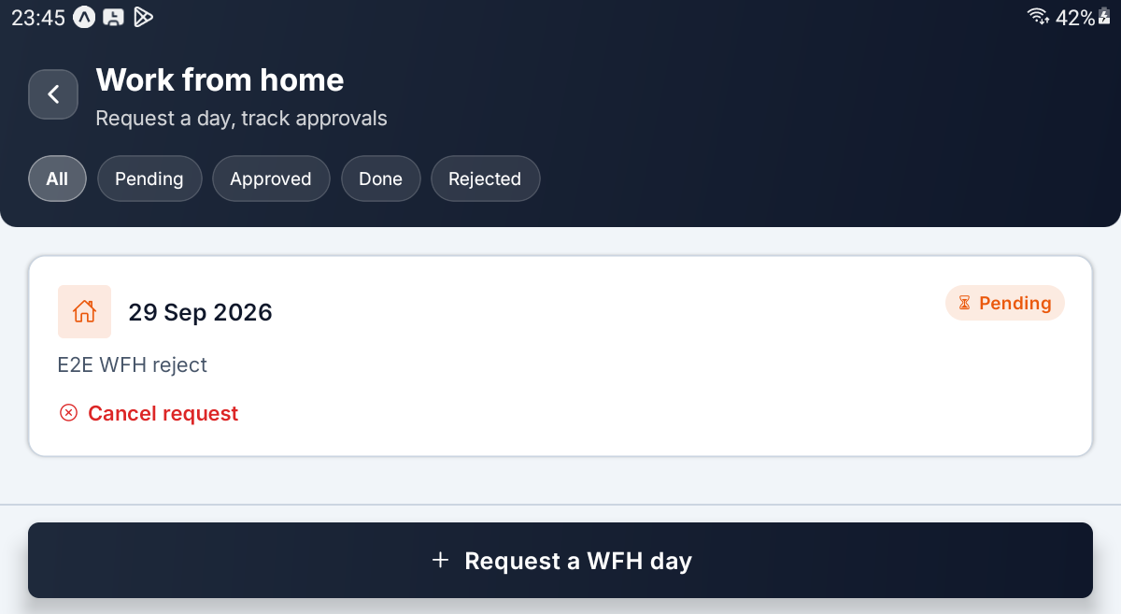
The Work from home list — a pending request with Cancel request, and Request a WFH day at the bottom

PART 6 YOUR RECORDS

Step 22 Look Back at Your Attendance
Tap My Attendance on Home. My attendance (Day-wise history) opens on the current month.
The arrows either side of the month name step back and forward. The forward arrow stops at the current month, since nothing is recorded ahead of today.
A summary card counts the month's Present, Late, Half Day, Leave, Absent and Day Off days, and adds a line such as 0h 00m worked across 1 recorded day.
Below it, one card per graded day shows the date, your in and out times, the hours worked, a WFH chip on work-from-home days, an amber line on days you were late, and the day's status chip. A month with nothing graded says Nothing recorded.
What you see | What it means
Present | On time, full day
Late | Arrived after the grace period
Half Day | Graded as half a day
Leave | Covered by approved leave
Absent | Expected in, never checked in
Day Off | A weekly off or holiday you worked; never counted against you

TIP This screen shows counts and times only. It never shows a money figure; questions about pay go to HR.

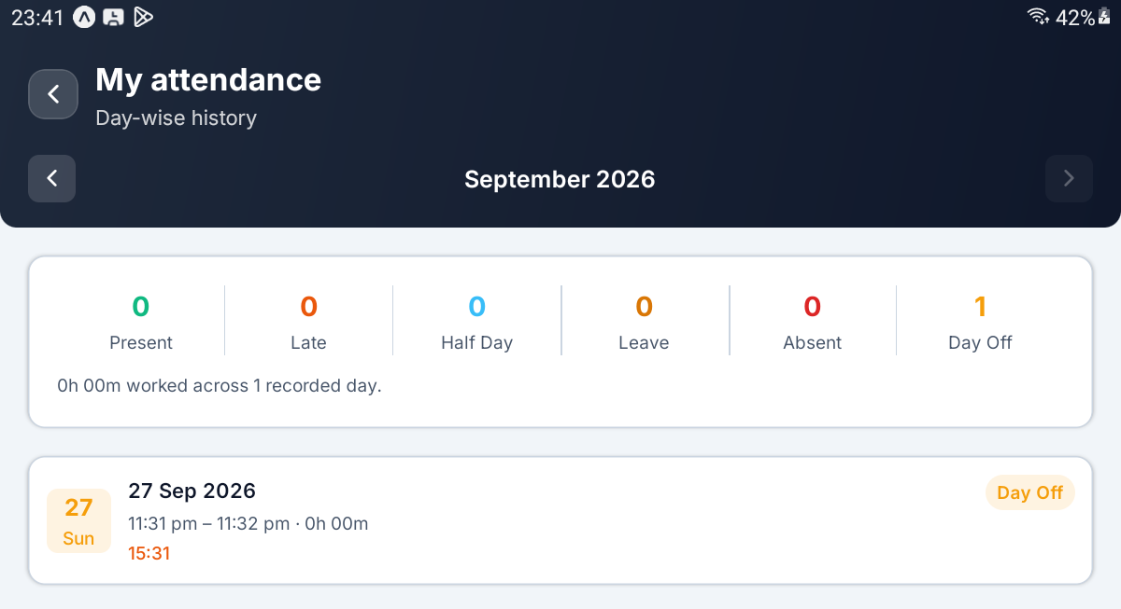
My attendance — the month arrows, the six-count summary, and a day card

Step 23 Check Your Details
Tap the Profile tab, or My Details on Home. My details shows an Account card with your Name and Username.
Further sections appear only if HR has switched them on: Personal (blood group, parents' names and emergency contacts), Qualifications and Previous employment. A field HR has switched on but nobody has filled in shows a dash. If HR has switched nothing on, you will see Nothing to show yet and Your HR team has not enabled any detail sections.
Everything here is read-only. To change your details, use My Profile in the web console, or ask HR for anything not shown.
What you see | What it means
A section with rows | HR has switched it on; the values come from your record
A dash in a row | That field is empty on your record
Nothing recorded yet. | A section is on, but nothing has been added to it
Nothing to show yet | HR has not switched on any sections

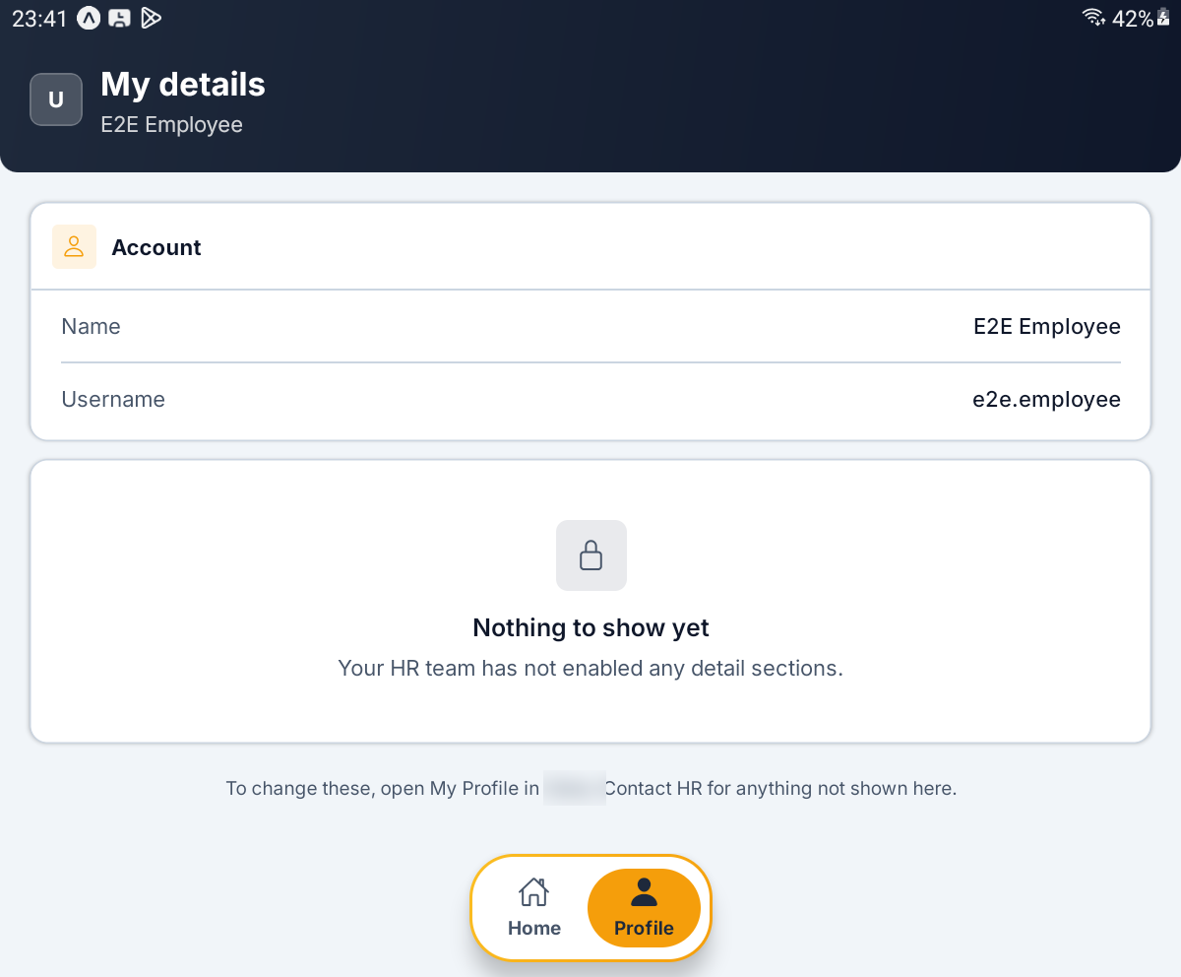
My details — the Account card, and the note shown when no sections are switched on

Step 24 See Which Server You Are On
Tap the gear at the top of Home. Settings (Server and account) shows one card, Connection, with four rows: Server, Database, Signed in as and Username.
Nothing here can be changed. It is there so you can read out exactly which server and account the phone is using when HR asks.
[ IMAGE 28 — not captured yet ]
Settings — the Connection card with Server, Database, Signed in as and Username

QUICK REFERENCE

Where Things Live
To do this | Go here
Start your day | Home → Check In
End your day | Home → Check Out
Work a weekly off or holiday | Home → I'm working today → Check In
Undo a day-off declaration | Home → Not working after all (before you check in)
See your leave balances | Apply Leave → Paid leave and Compensatory off cards
Apply for leave | Apply Leave → Apply for leave
Spend a comp-off | Apply for leave → Comp-off
Withdraw a pending request | The request's card → Cancel request
Cancel approved leave | The request's card → Request cancellation → Send to HR
Ask to work from home | Work From Home → Request a WFH day
See a past month | My Attendance → the month arrows
Check your personal details | Profile tab
See which server you are on | The gear on Home → Settings
Sign out | The log-out button on Home → Log out
Change server | Sign out, then Change URL on the sign-in screen

Things to Remember
▪ One check-in and one check-out a day. Once you check out, you cannot check in again until tomorrow.
▪ Check Out has no confirmation. Do not tap it until you are really leaving.
▪ Declare a day off before you check in. On a weekly off or holiday, tap I'm working today first, or the check-in will be refused.
▪ The Loss of Pay warning never blocks you. Read it before you submit; the server itself works out the figure.
▪ Paid leave is whole days and does not carry forward. Only comp-off can be taken as a half day.
▪ Approved leave goes back through HR. Use Request cancellation, and do it before that month's payroll is confirmed.
▪ A WFH day uses the ordinary Check In. There is no separate button, and the app never reads your location.
▪ There is no offline mode. Every check-in and request goes straight to the server, so you need a connection.
▪ The bell does nothing yet. It always says No new notifications.
▪ Pull down to refresh. Home, Leave, Work from home, My attendance and My details all update this way.
▪ You stay signed in until you log out. Logging out keeps the server; Change URL forgets it.
Check in when you start, check out when you finish, and ask for the rest. Everything else in this guide is detail.

— End of Guide —
Alphalize Technologies | 369 Attendance Employee Guide

